

# MEASUREMENTS AND INSTRUMENTATION LAB

# MINI PROJECT

# SYNOPSIS

# 18/08/2023

|  |  |  |  |
| --- | --- | --- | --- |
| REGISTRATION NO. | NAME | ROLL NO | CLASS |
| 210906204 | **SHASHANK PANDEY** | **26** | **EEE-B** |
| 210906206 | **TITHI MISHRA** | **27** | **EEE-B** |
| 210906130 | **PRAANZAL PRAYAS** | **17** | **EEE-B** |

## PROBLEM STATEMENT

“Design system level solutions or processes for engineering problems that meet the specified needs with appropriate consideration for public health and safety, and/or cultural, societal, and/or environmental considerations with an understanding of the limitations.”

## TITLE OF THE PROJECT

**PLANT CARE SYSTEM – SOIL MOISTURE AND LIGHT INTENSITY LEVEL DETECTOR**

## INTRODUCTION

The "Plant Care System – Soil Moisture and Light Intensity Level Detector" project represents a pioneering approach to addressing the growing need for efficient and sustainable plant care in various settings, including homes, gardens, agricultural fields, and urban environments.

This project aims to harness the power of modern technology to create a comprehensive and intelligent plant care solution that goes beyond traditional methods. By combining advanced sensors, Arduino, Wi-Fi Modules and user-friendly interfaces, this system endeavors to revolutionize how we nurture and sustain plant life.

With the relentless advancement of urbanization and the expansion of indoor cultivation practices, the necessity for automated and data-driven plant care has become more evident. proposed plant care system seeks to bridge this gap by providing accurate, real-time information on soil moisture content and light availability.

Beyond its immediate applications, this project addresses broader considerations encompassing public health, environmental stewardship, and societal well-being. Improved air quality, reduced stress levels, and aesthetic enhancement are only a few of the positive outcomes that can stem from healthier plant ecosystems. Additionally, by promoting responsible water usage and energy conservation, the project aligns with sustainability goals and contributes to reducing the ecological footprint associated with plant care.

The integration of a user-friendly interface ensures that this technology is accessible to both gardening enthusiasts and professionals.

## OBJECTIVES

1. **Main objective:** To make an efficient Plant Care System which takes care of our miniature garden even when we are not at home.
2. To measure the light intensity received by the phototropins of plants.
3. To measure the moisture content of the soil and whether or not it’s adequate for our plant.
4. To improve public health, environment and societal well-being.

## METHEDOLOGY

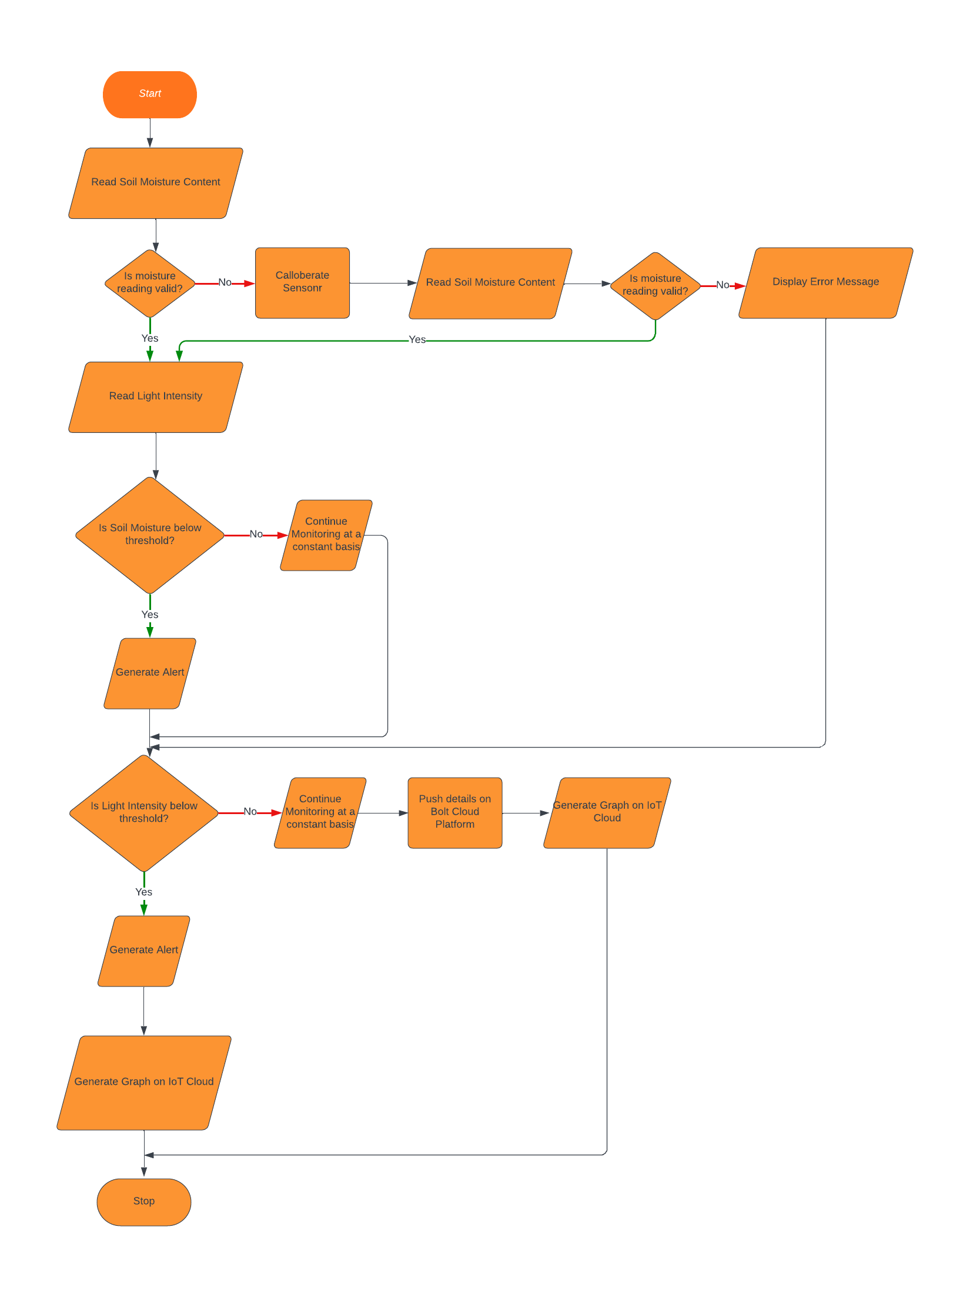

# JUSTIFICATION AS PER PROBLEM STATEMENT

An efficient plant care system with integrated light intensity monitoring and soil moisture level detection provides numerous benefits that extend beyond individual plant health. This system contributes to public health and safety, as well as cultural, societal, and environmental considerations, in the following ways:

1. **Public Health and Safety**
   1. Air Quality Improvement: Since plants play a crucial role in air purification by absorbing pollutants and releasing oxygen hence a healthy vegetation environment translates to cleaner air, which positively impacts respiratory health and reduces the risk of airborne diseases.
   2. Allergen Reduction: Well-maintained plants can reduce indoor allergens, lowering the occurrence of allergies or respiratory irritations.
   3. Stress Reduction: Researches have shown that the presence of greenery has been linked to reduced cortisol level hence decreasing stress levels and improved mental well-being.
2. **Cultural and Societal Considerations**: A well-maintained plant care system adds beauty and harmony to urban and indoor spaces, fostering a sense of cultural identity and pride.
3. **Environmental Considerations**
   1. Biodiversity Support: Maintaining healthy plant ecosystems supports local biodiversity by providing habitat and food sources for various species, including pollinators.
   2. Carbon Sequestration: As plants capture and store carbon dioxide, a thriving plant environment helps reduce greenhouse gas emissions and supports sustainability efforts.
4. **Sustainability and Resource Conservation**
   1. Water Efficiency: Integrating a soil moisture level detection system helps optimize watering practices, minimizing water wastage and promoting responsible water usage.
   2. Energy Conservation: The light intensity monitor ensures that plants receive the appropriate amount of light. This reduces energy consumption associated with excessive lighting and contributes to energy-efficient practices.

In conclusion, an efficient plant care system with light intensity monitoring and soil moisture level detection contributes to public health, safety, cultural enrichment, societal well-being, environmental sustainability, and resource conservation. By addressing these multifaceted considerations, such a system enhances the quality of life for individuals, communities, and the environment as a whole.

## TOOLS AND TECHNOLOGIES USED

1. LabView
2. Arduino Software Editor
3. VS Code
4. Bolt IOT Cloud Platform
5. Git and GitHub
6. JavaScript and HTML

## HARDWARE COMPONENTS AND TENTATIVE BILL

|  |  |  |
| --- | --- | --- |
| Serial No. | Component | Price |
| 1. | ATMEG2560 | 1500/- |
| 2. | Bolt Wi-Fi Module | 1500/- |
| 3. | Breadboard | 50/- |
| 4. | Light Detecting Resistor | 80/- |
| 5. | Jumper Wires | 50/- |
| 6. | Soil Moisture Sensor | 40/- |
|  | LEDs (Pack of 5 different Colours) | 80/- |
|  | Resistor Kit | 50/- |
|  | Extra Supplies | 500/- |
|  | Stationery | 200/- |
|  | Logistics and Travel | 400/- |
|  | TOTAL | 4450/- |

Total Estimate in words = Four Thousand Four Hundred and Fifty only.

## TIMELINE

|  |  |  |
| --- | --- | --- |
| Week | Work Details | Outcome |
| 1 | Definition of the Problem Statement | Decided to do something related to an environment related issue. |
| 2 | * Project Idea * Components to be used * Methodology to be followed * Justification of our Problem Statement | * Construction of Plant Care System * Flowchart of the Solution |
|  | * Decision on integration Arduino into LabVIEW * Decision of Bolt Wi-Fi Integration into LabVIEW * Writing the Synopsis * Discussion on the total bill and difficulties to overcome | * Arduino can be integrated through installation of NI VISA * Currently we are yet to figure out about the integration of Bolt Module into LabVIEW * A ready, readable and well-designed Synopsis doc. |